**Marketing Employee Salary Calculation - Documentation**

**Project Content**

A web-based application developed using Python and Flask that calculates and manages the salaries of marketing employees based on their performance, working hours, commissions, and incentives.

Includes:

- Flask-based backend to handle salary calculations.

- HTML templates for form input and displaying results.

- A salary model that factors in base pay, working hours, sales commissions, bonuses, and deductions.

- Modular and scalable codebase.

**Project Code**

--- app.py ---

from flask import Flask, render_template, request

app = Flask(__name__)

def calculate_salary(base_salary, hours_worked, commission, bonus):

hourly_rate = base_salary / 160 # assuming 160 working hours/month

return base_salary + (hours_worked * hourly_rate) + commission + bonus

@app.route("/", methods=["GET", "POST"])

def index():

if request.method == "POST":

name = request.form["name"]

base = float(request.form["base_salary"])

hours = float(request.form["hours_worked"])

comm = float(request.form["commission"])

bonus = float(request.form["bonus"])

total_salary = calculate_salary(base, hours, comm, bonus)

return render_template("result.html", name=name, total_salary=total_salary)

return render_template("index.html")

if __name__ == "__main__":

app.run(debug=True)

--- index.html ---

<!DOCTYPE html>

<html>

<head><title>Salary Calculator</title></head>

<body>

<h1>Marketing Employee Salary Calculator</h1>

<form method="post">

Name: <input type="text" name="name" required><br><br>

Base Salary: <input type="number" name="base_salary" required><br><br>

Hours Worked: <input type="number" name="hours_worked" required><br><br>

Commission: <input type="number" name="commission" required><br><br>

Bonus: <input type="number" name="bonus" required><br><br>

<input type="submit" value="Calculate Salary">

</form>

</body>

</html>

--- result.html ---

<!DOCTYPE html>

<html>

<head><title>Salary Result</title></head>

<body>

<h2>Salary Calculation Result</h2>

<p><strong>Name:</strong> {{ name }}</p>

<p><strong>Total Salary:</strong> ${{ total_salary }}</p>

<a href="/">Calculate Another</a>

</body>

</html>

**Key Technologies**

- Python 3.x

- Flask Web Framework

- HTML5/CSS3 (for UI)

- Optional: SQLite / SQLAlchemy for future data storage

**Description**

Designed for marketing teams to help HR or finance departments compute employee salaries based on key performance metrics.

Takes into account:

- Base Salary

- Hours Worked

- Sales Commission

- Bonus or Incentives

Calculates total salary dynamically and presents it in a user-friendly format.

**Output**

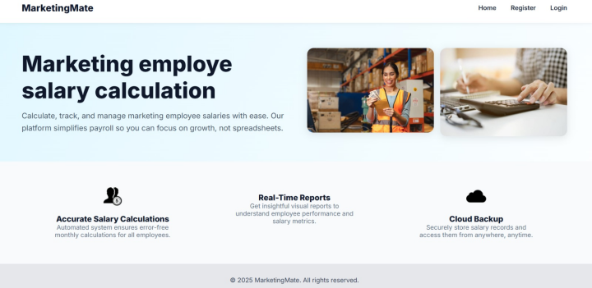

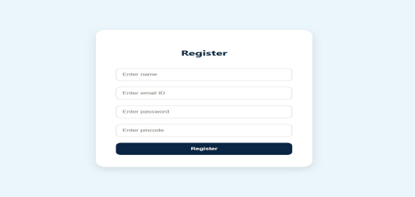

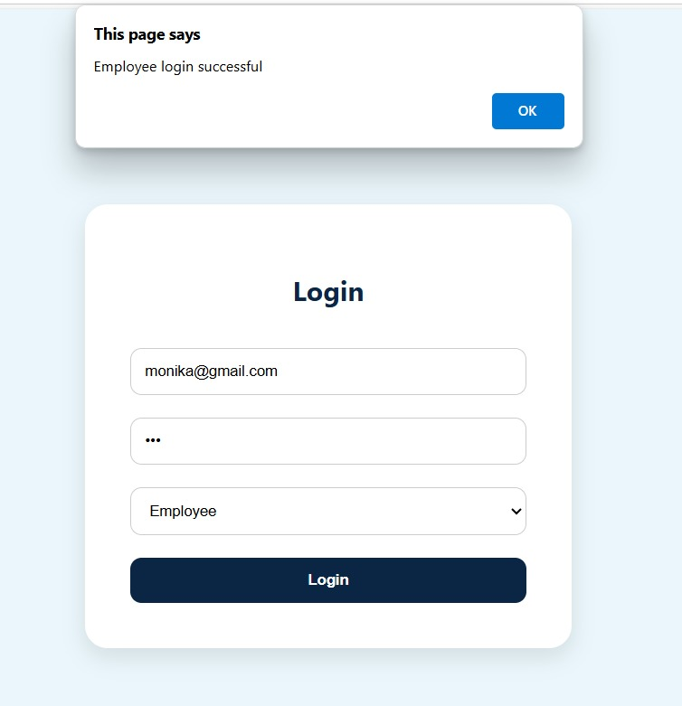

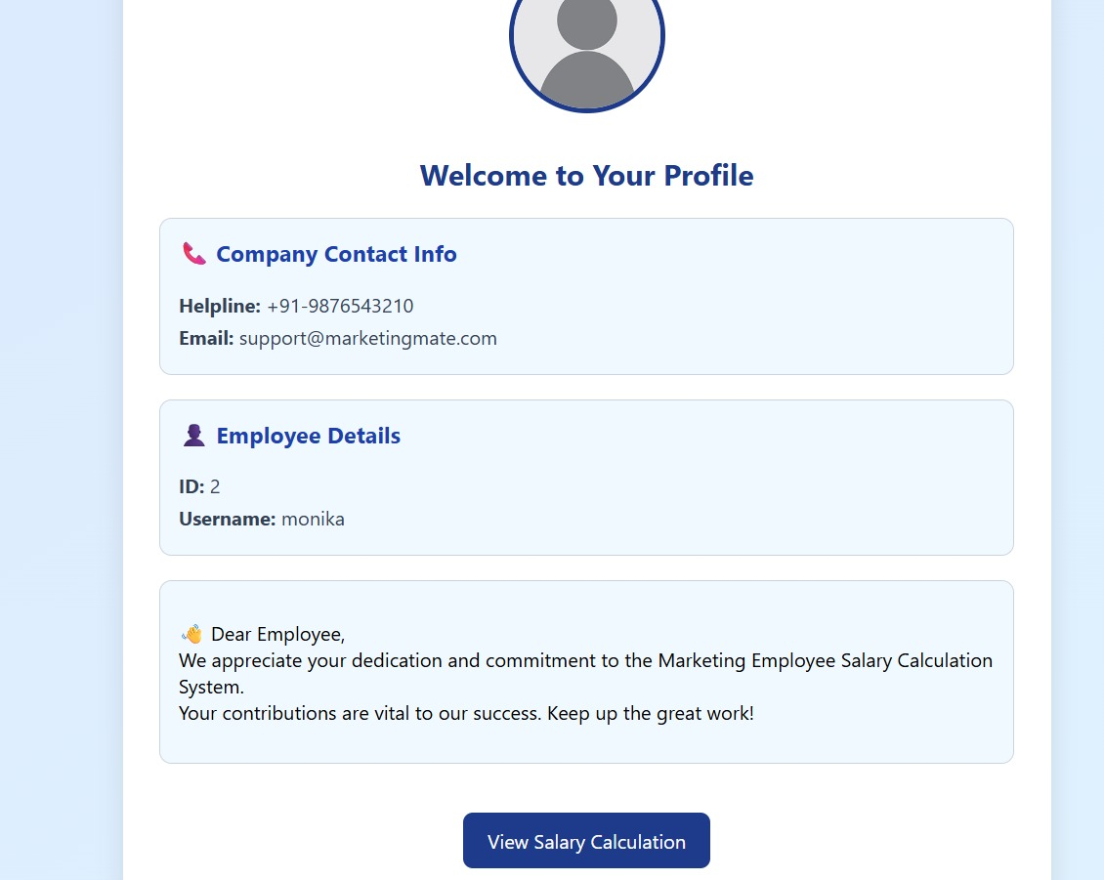

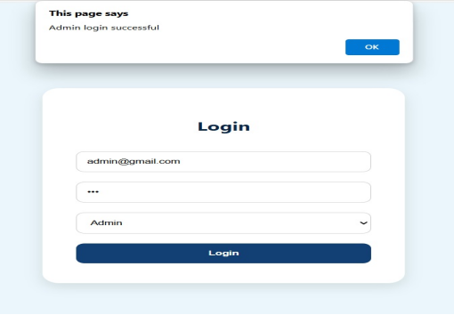

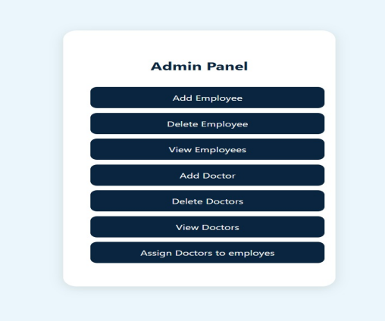

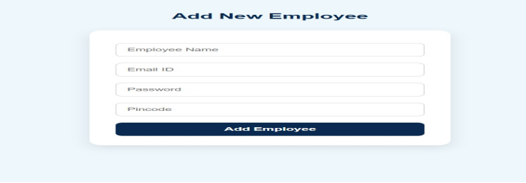

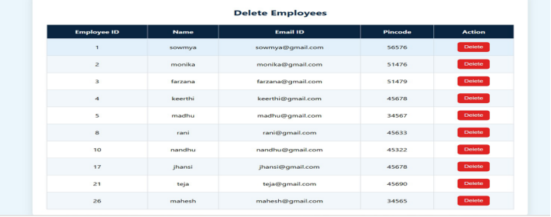

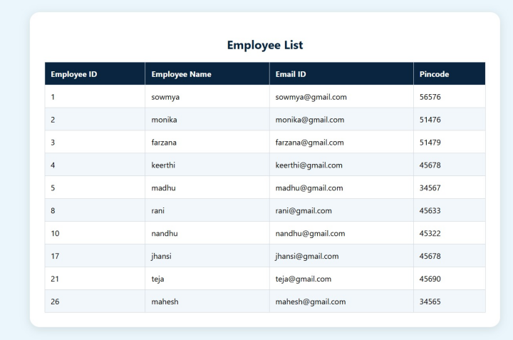

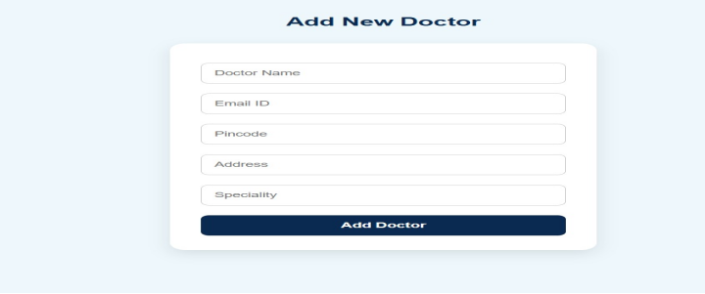

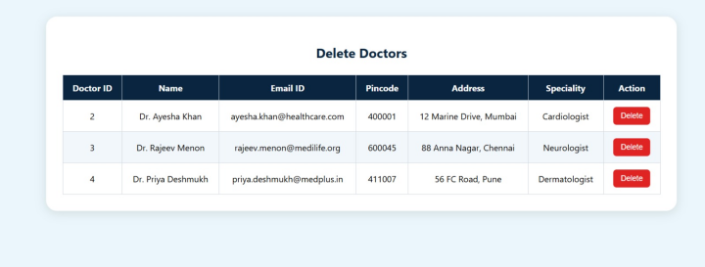

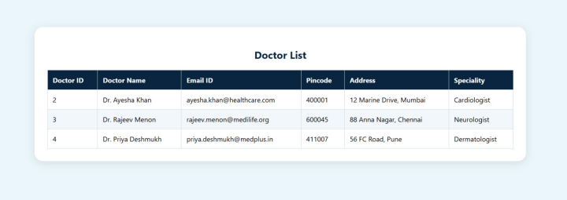

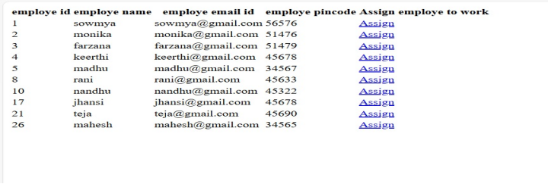

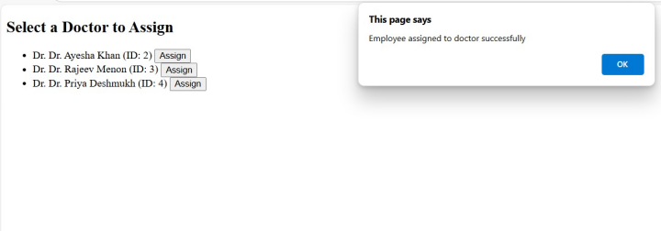

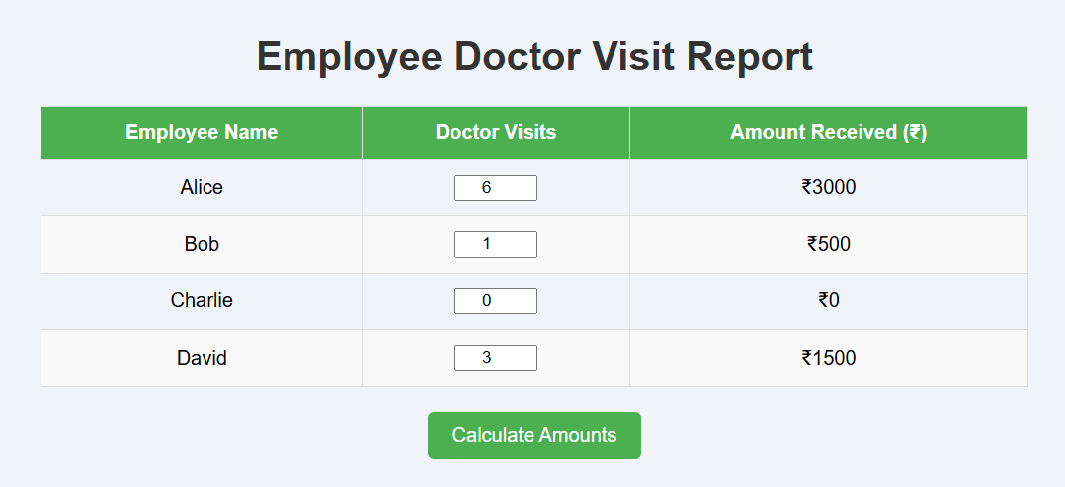

**Further Research**

- Add database integration for record-keeping.

- Implement login for employees/admins.

- Integrate APIs to auto-calculate commissions.

- Add tax/deduction logic.

- Export reports in PDF or Excel.